**DAY-2:**

**File Permissions in LINUX:**

**Changing Permissions for different users in LINUX:**

* One of the major reasons of why linux is more secure than windows

**Types of users:**

* User : owner of the file
* Group : the group that owns the file
* Others : all other users on the system

1. **Chmod : Modify file permissions**

Changing the mode of access for different users:

* Syntax:

1. Octal mode:

Chmod ugo file_name

R - 4

W - 2

X - 1

* example:

Chmod 755 file.txt // sets permissions to rwxr-xr-x

1. Syntax mode:

Chmod u+rwx,g_rw,o_rw file_name

1. **Chown : changing the owner of file or directory**

* syntax:

Chown new_owner file_name

Chown new_owner:new_group file_name

**Shell Scripting :**

**What is Shell?**

* An environment that takes the commands from user and calls the OS to run those commands.
* A program that acts as the interface between user and the LINUX system.
* Allows users to enter for OS to execute.
* Accepts the commands in english and converts them in native binary language.

**Types of shells:**

Bourne shell :

C shell : C programming

Korn shell : combo of bourne and C shell

Bash shell: Born again shell- an extended version of all the above 3.

Tcsh shell

**Finding shells in system:**

* Command to final all available shells in system:

cat/etc/shells

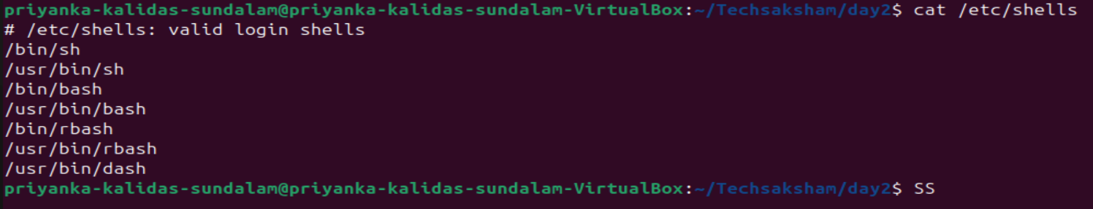

**What is Shell Scripting:**

* Shell script is a plain text file that contains a series of commands
* Script means write program at one place and run it anywhere.
* Can be used to automate administrative tasks.
* The ability to combine commands **allows you to create new commands** - beauty of LINUX
* Practical examples:

Monitoring the system

Data backup & snapshots

Find out all logged in users and what they are doing

**Writing Shell Script:**

* Shell programs with **.sh** extensions.
* Create a file using commands like touch, nano or cat.

Nano file.sh

* Shell program compulsorily starts with :

#!/bin/bash

* Write the shell program and save :

1. If - else rpogram:

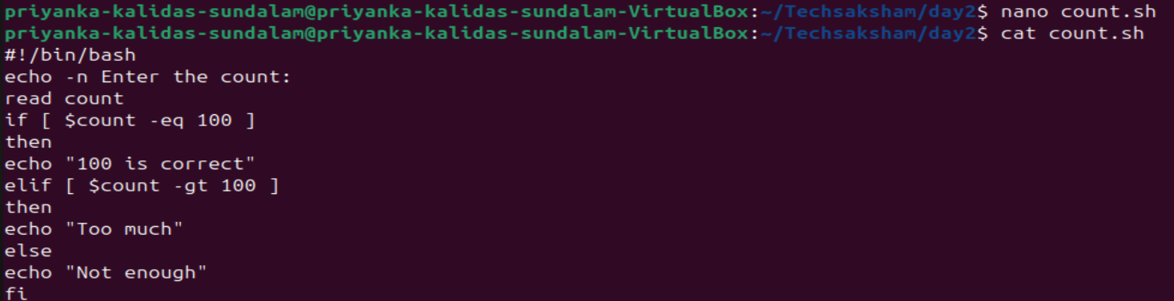

* Output:

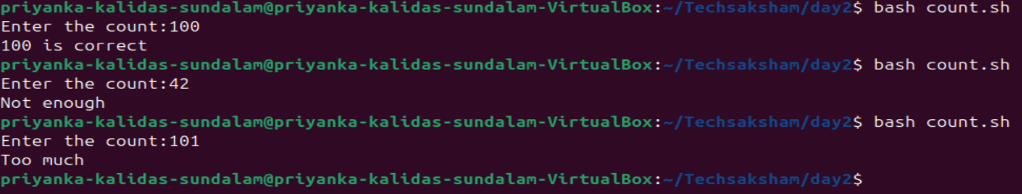

1. For loop:

* Program:

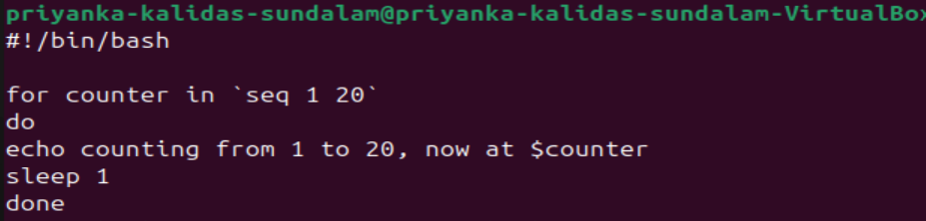

* Output:

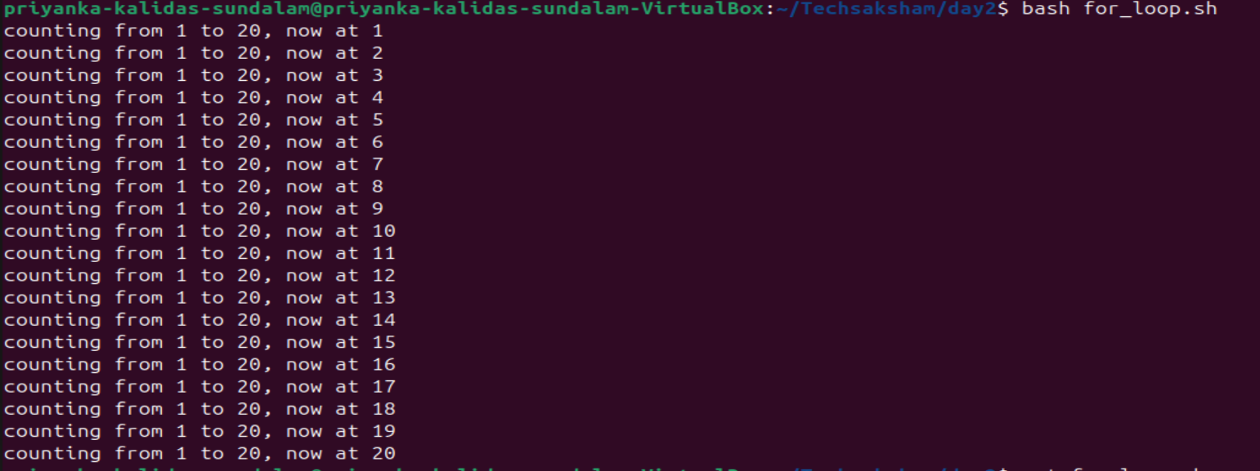

1. While loop:

* Program:

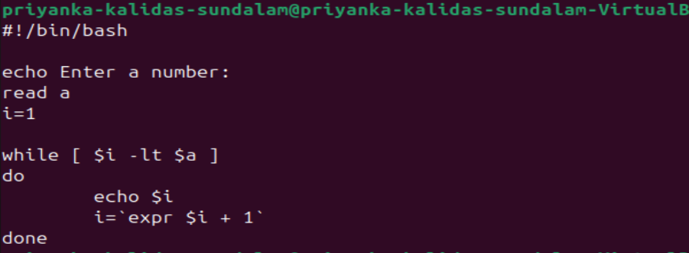

* Output:

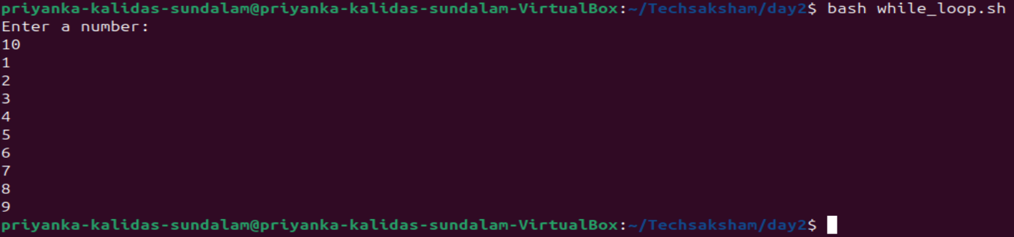

**SSH:**

* SSH - Secure shell
* Transfers data in encrypted form between host to client
* Uses TCP/IP port for ssh : 22
* Syntax to connect to another computer:

**Ssh ip_addr**

**SCP:**

* Allows to copy files over ssh connections.
* Useful in transferring the files between computers
* syntax:

**Scp file_name yourusername@yourserver:/home/yourusername/**